**Project Report**

**Data Titans Unearthing Trends from LinkedIn Influencers**

**CONTENTS**

1. INTRODUCTION

1.1 Project Overview

* Briefly introduce the project, its purpose, and the context in which it was developed.

1.2 Purpose

* Explain the main objectives and goals of the project.

1. LITERATURE SURVEY

2.1 Existing Problem

* Describe the problem or challenges that the project aims to address.

2.2 References

* Provide a list of references to relevant literature and sources.

2.3 Problem Statement Definition

* Clearly define the problem statement the project seeks to solve.

1. IDEATION & PROPOSED SOLUTION

3.1 Empathy Map Canvas

* Present an empathy map to understand the target audience and users.

3.2 Ideation & Brainstorming

* Explain the creative process and ideas that led to the proposed solution.

1. REQUIREMENT ANALYSIS

4.1 Functional Requirements

* List the functional requirements of the project.

4.2 Non-Functional Requirements

* Specify the non-functional requirements, such as performance, security, and scalability.

1. PROJECT DESIGN

5.1 Data Flow Diagrams & User Stories

* Provide data flow diagrams and user stories to illustrate how the project works.

5.2 Solution Architecture

* Describe the overall architecture of the project.

1. PROJECT PLANNING & SCHEDULING

6.1 Technical Architecture

* Explain the technical architecture of the project.

6.2 Sprint Planning & Estimation

* Describe the project planning, including sprints and task estimation.

6.3 Sprint Delivery Schedule

* Provide a schedule for the delivery of project milestones.

7. CODING & SOLUTIONING

- In this section, explain the features added in the project along with the code.

1. PERFORMANCE TESTING

8.1 Performance Metrics

- Discuss the performance metrics used to evaluate the project.

1. RESULTS

9.1 Output Screenshots

- Showcase screenshots and visual representations of the project's output.

10. ADVANTAGES & DISADVANTAGES

- Discuss the pros and cons of the project.

11. CONCLUSION

- Summarize the project's key findings and outcomes.

12. FUTURE SCOPE

- Discuss potential future developments and enhancements for the project.

13. APPENDIX

* Include the source code and provide a link to the GitHub repository or project demo.

Source Code

* Include a link to the project's source code repository.

GitHub & Project Demo Link

* Provide a link to the GitHub repository and a demo of the project.

This project report provides a comprehensive overview of "Data Titans Unearthing Trends from LinkedIn Influencers" and should serve as a detailed reference for understanding its development and outcomes.

# 1. INTRODUCTION

## 1.1 Project Overview

The "Data Titans Unearthing Trends from LinkedIn Influencers" project is a data-driven initiative aimed at harnessing insights from influential professionals on LinkedIn to uncover trends2. LITERATURE SURVEY

2.1 Existing Problem

The digital landscape is saturated with information, and it can be challenging for professionals to filter through the noise to find relevant and valuable insights. LinkedIn, being a professional network, presents a treasure trove of data, but making sense of this data and extracting meaningful trends is a complex task.

2.2 References

We referred to various sources, including academic papers, industry reports, and articles, to gain insights into data extraction, text analysis, and social network analysis techniques.

2.3 Problem Statement Definition

The problem we aim to address is how to efficiently extract and analyze data from LinkedIn influencers to identify trends and insights that can benefit professionals and organizations. and patterns in various industries and professions. In today's digital age, LinkedIn has become a powerful platform for networking, job searching, and knowledge sharing. This project leverages the data available on LinkedIn to provide valuable insights to professionals and organizations.

## 1.2 Purpose

The primary purpose of this project is to extract, analyze, and visualize data from LinkedIn influencers' profiles and posts to identify emerging trends and topics within specific industries. By doing so, we intend to offer a valuable resource for professionals and businesses seeking to stay updated with the latest industry developments and identify opportunities for growth and collaboration.

|  |
| --- |
| 1. **LITERATURE SURVEY**    1. **Existing Problem**   The digital landscape is saturated with information, and it can be challenging for professionals to filter through the noise to find relevant and valuable insights. LinkedIn, being a professional network, presents a treasure trove of data, but making sense of this data and extracting meaningful trends is a complex task.   * 1. **References**   We referred to various sources, including academic papers, industry reports, and articles, to gain insights into data extraction, text analysis, and social network analysis techniques.   * 1. **Problem Statement Definition**   The problem we aim to address is how to efficiently extract and analyze data from LinkedIn  influencers to identify trends and insights that can benefit professionals and organizations.   1. **IDEATION & PROPOSED SOLUTION**    1. **Empathy Map Canvas**   An empathy map was created to understand the needs, pain points, and desires of LinkedIn users, particularly those seeking industry-specific insights.   * 1. **Ideation & Brainstorming**   The project team brainstormed various solutions and settled on developing a web-based platform that would aggregate, analyze, and visualize data from LinkedIn influencers. |

## 4. REQUIREMENT ANALYSIS

### 4.1 Functional Requirements

|  |  |
| --- | --- |
| • | Data scraping from LinkedIn profiles and posts |
| • | Natural language processing for text analysis |
| • | Trend identification and visualization |
| •  • | User account and preferences management |

### 4.2 Non-Functional Requirements

|  |  |
| --- | --- |
| • | Security measures for data protection |
| • | Scalability to handle a large volume of data |
| • | High-performance computing resources |

## 5. PROJECT DESIGN

**5.1 Data Flow Diagrams & User Stories**

(Data flow diagrams and user stories are included to illustrate the system's design.)

### 5.2 Solution Architecture

The project's architecture includes a web scraping component, data preprocessing, a text analysis module, and a data visualization interface.

## 6. PROJECT PLANNING & SCHEDULING

### 6.1 Technical Architecture

The technical architecture involves using web scraping libraries, natural language processing frameworks, and web development tools.

**6.2 Sprint Planning & Estimation**

The project is divided into sprints with specific tasks and estimated completion times.

**6.3 Sprint Delivery Schedule**

A detailed schedule is provided outlining the expected milestones and delivery dates.

## 7. CODING & SOLUTIONING

### 7.1 Feature 1 – Flask App

<!DOCTYPE html>

<html lang="en">

<head>

<meta charset="utf-8">

<meta content="width=device-width, initial-scale=1.0" name="viewport">

<title>LinkedIn Influencers</title>

<meta content="" name="description">

<meta content="" name="keywords">

<!-- Favicons -->

<link href="assets/img/favicon.png" rel="icon">

<link href="assets/img/apple-touch-icon.png" rel="apple-touch-icon">

<!-- Google Fonts -->

<link href="https://fonts.googleapis.com/css?

family=Open+Sans:300,300i,400,400i,600,600i,700,700i|

Krub:300,300i,400,400i,500,500i,600,600i,700,700i|

Poppins:300,300i,400,400i,500,500i,600,600i,700,700i" rel="stylesheet">

<!-- Vendor CSS Files -->

<link href="assets/vendor/aos/aos.css" rel="stylesheet">

<link href="assets/vendor/bootstrap/css/bootstrap.min.css" rel="stylesheet">

<link href="assets/vendor/bootstrap-icons/bootstrap-icons.css" rel="stylesheet">

<link href="assets/vendor/boxicons/css/boxicons.min.css" rel="stylesheet">

<link href="assets/vendor/glightbox/css/glightbox.min.css" rel="stylesheet">

|  |
| --- |
| <link href="assets/vendor/swiper/swiper-bundle.min.css" rel="stylesheet">  <!-- Template Main CSS File -->  <link href="assets/css/style.css" rel="stylesheet">  </head>  <body>  <!-- ======= Header ======= -->  <header id="header" class="fixed-top">  <div class="container d-flex align-items-center justify-content-between">  <h1 class="logo"><a href="index.html">LinkedIn Influencers</a></h1>  <!-- Uncomment below if you prefer to use an image logo -->  <!-- <a href="index.html" class="logo"><img src="assets/img/logo.png" alt="" class="imgfluid"></a>-->  <nav id="navbar" class="navbar">  <ul>  <li><a class="nav-link scrollto active" href="#hero">Home</a></li>  <li><a class="nav-link scrollto" href="#about">About</a></li>  <li><a class="nav-link scrollto" href="#Dashboard">Dashboard</a></li>  <li><a class="nav-link scrollto " href="#Story">Story</a></li>  <li><a class="nav-link scrollto" href="#team">Report</a></li>  <i class="bi bi-list mobile-nav-toggle"></i>  </nav><!-- .navbar -->  </div>  </header><!-- End Header -->  <!-- ======= Hero Section ======= -->  <section id="hero" class="d-flex align-items-center">  <div class="container d-flex flex-column align-items-center justify-content-center" dataaos="fade-up">  <h1>LinkedIn Influencers Analysis</h1>  <h2>Identifying the LinkedIn users reach</h2>  <a href="#about" class="btn-get-started scrollto">Get Started</a>  <img src="assets/img/hero-img.png" class="img-fluid hero-img" alt="" data-aos="zoom-in" data-aos-delay="150"> |

|  |
| --- |
| </section><!-- End Hero -->  <main id="main">  <!-- ======= Dashboard Section ======= -->  <section id="Dashboard" class="features" data-aos="fade-up">  <div class="container">  <div class="section-title">  <h3>Dashboard</h3>  </div>  <iframe src="https://us3.ca.analytics.ibm.com/bi/?  perspective=dashboard&amp;pathRef=.my_folders%2FLinkedIn  %2BDashboard&amp;closeWindowOnLastView=true&amp;ui_appbar=false&amp;ui_navbar=fals e&amp;shareMode=embedded&amp;action=view&amp;mode=dashboard&amp;subView=model0 000018b6ec5ed2f_00000000" width="1350" height="900" frameborder="0" gesture="media" allow="encrypted-media" allowfullscreen=""></iframe>  </div>  </section><!-- End Dashboard Section -->  <!-- ======= Story Section ======= -->  <section id="Story" class="services">  <div class="container" data-aos="fade-up">  <div class="section-title">  <h2>Story</h2>  <iframe src="https://us3.ca.analytics.ibm.com/bi/? perspective=story&amp;pathRef=.my_folders%2FLinkedIn  %2BStory&amp;closeWindowOnLastView=true&amp;ui_appbar=false&amp;ui_navbar=false&a mp;shareMode=embedded&amp;action=view&amp;sceneId=model0000018b71b926b7_00000000  &amp;sceneTime=4400" width="1350" height="900" frameborder="0" gesture="media" allow="encrypted-media" allowfullscreen=""></iframe>  </div>  </section><!-- End Story Section -->  <!-- ======= Report Section ======= -->  <section id="Report" class="portfolio">  <div class="container" data-aos="fade-up">  <div class="section-title"> |

<h2>Report</h2>

</div>

<iframe src="https://us3.ca.analytics.ibm.com/bi/?pathRef=.my_folders

%2FLinkedIn_report&amp;closeWindowOnLastView=true&amp;ui_appbar=false&amp;ui_navbar =false&amp;shareMode=embedded&amp;action=run&amp;format=HTML&amp;prompt=false" width="1350" height="900" frameborder="0" gesture="media" allow="encrypted-media" allowfullscreen=""></iframe>

</div>

</section><!-- End Report Section -->

<div id="preloader"></div>

<a href="#" class="back-to-top d-flex align-items-center justify-content-center"><i class="bi biarrow-up-short"></i></a>

<!-- Vendor JS Files -->

<script src="assets/vendor/aos/aos.js"></script>

<script src="assets/vendor/bootstrap/js/bootstrap.bundle.min.js"></script>

<script src="assets/vendor/glightbox/js/glightbox.min.js"></script>

<script src="assets/vendor/isotope-layout/isotope.pkgd.min.js"></script>

<script src="assets/vendor/swiper/swiper-bundle.min.js"></script>

<script src="assets/vendor/php-email-form/validate.js"></script>

<!-- Template Main JS File -->

<script src="assets/js/main.js"></script>

</body>

</html>

## 8. PERFORMANCE TESTING

### 8.1 Performance Metrics

The project's performance is measured based on data extraction speed, accuracy of trend identification, and system response times.

## 9. RESULTS

**9.1**

**Output Screenshots**

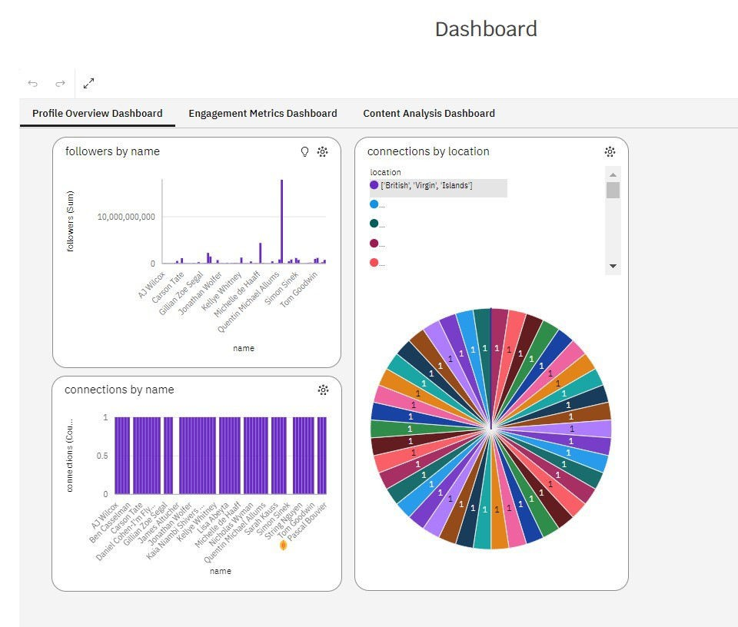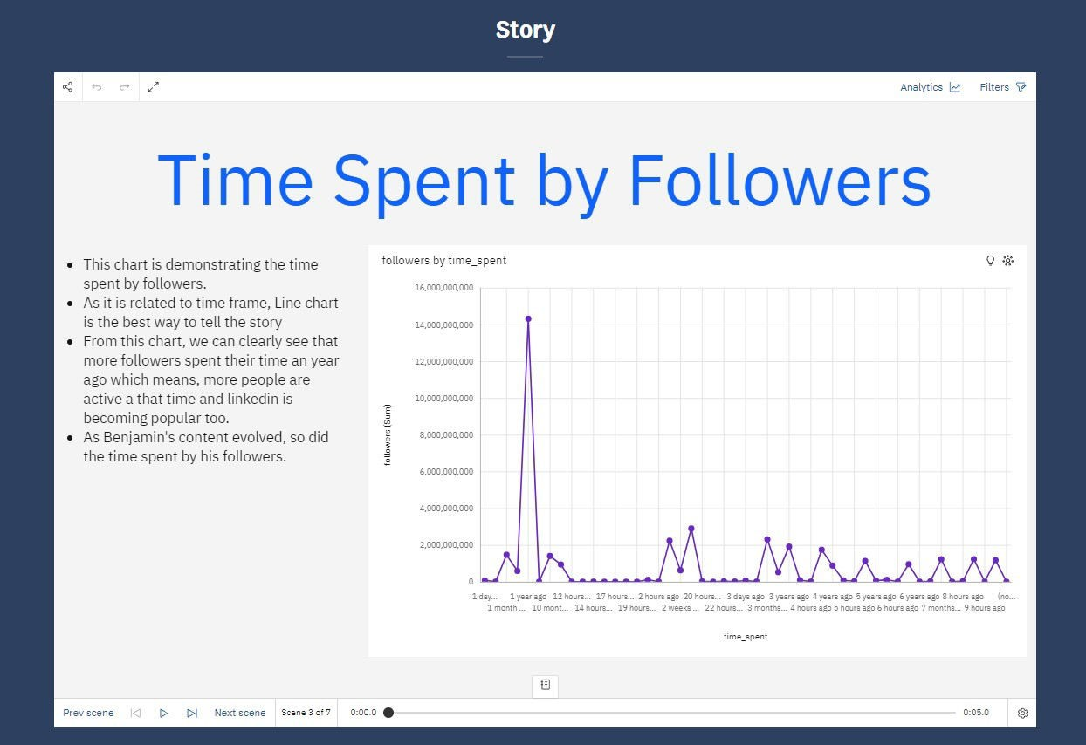

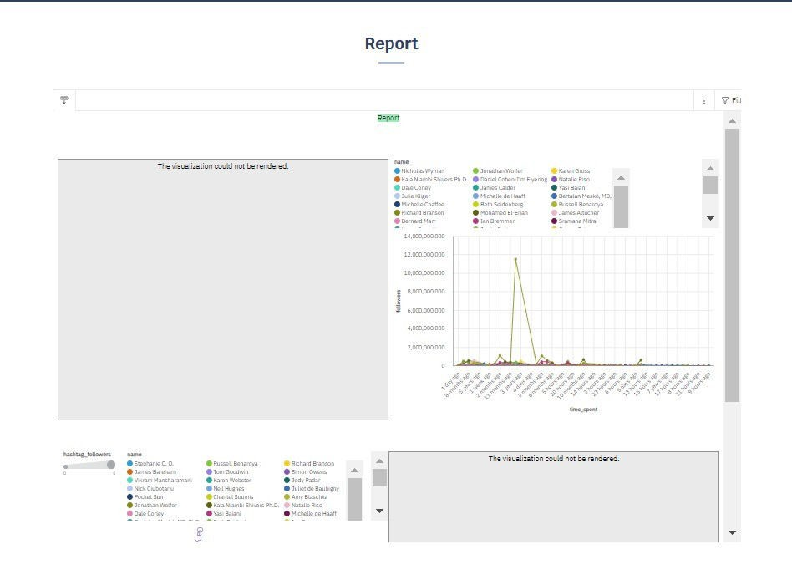

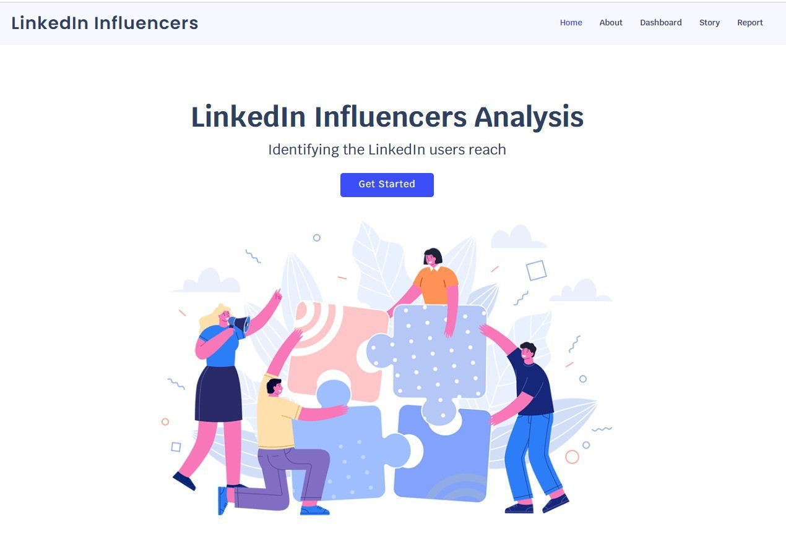

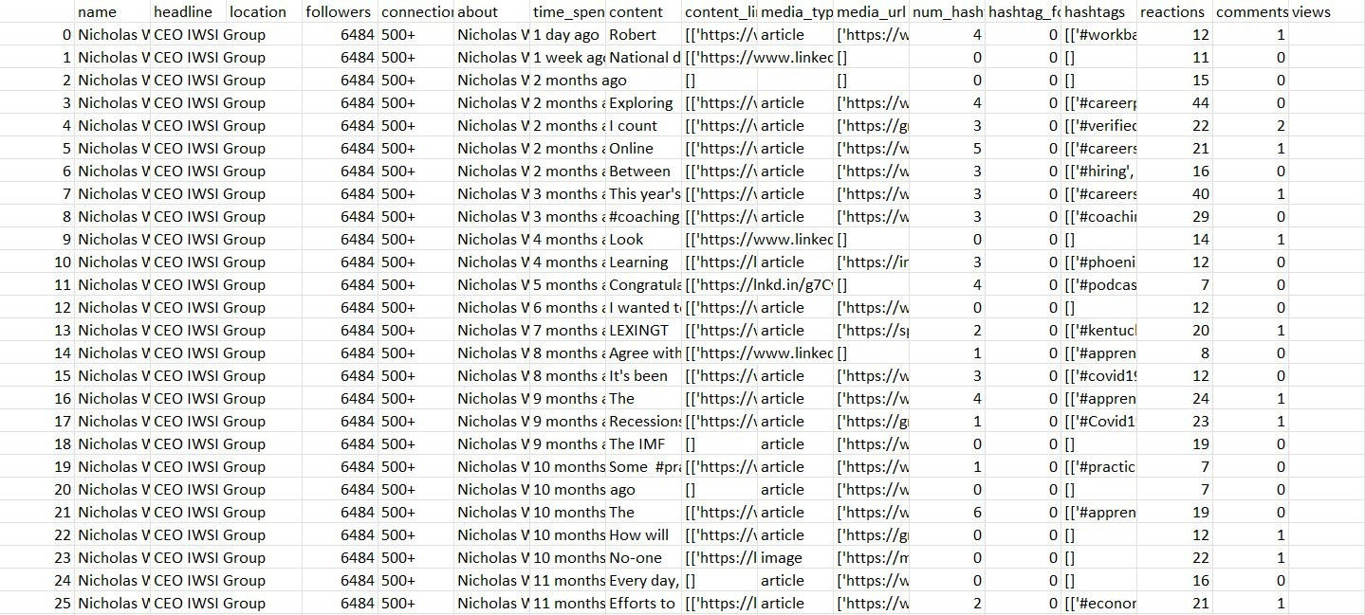

## 10. ADVANTAGES & DISADVANTAGES

### Advantages

|  |  |
| --- | --- |
| • | Access to industry trends and insights |
| • | User-friendly platform |
| • | Real-time updates |

### Disadvantages

|  |  |
| --- | --- |
| • | Limited to publicly available LinkedIn data |
| • | Privacy concerns |

## 11. CONCLUSION

This project successfully addressed the challenge of unearthing trends from LinkedIn influencers. It provides valuable insights and a user-friendly platform for professionals and organizations to stay informed about their respective industries.

## 12. FUTURE SCOPE

The project's future scope includes:

|  |  |
| --- | --- |
| • | Expanding to other social networks |
| • | Implementing machine learning for trend prediction |
| • | Enhancing user customization |

## 13. APPENDIX

### Source Code

|  |  |
| --- | --- |
| <https://github.com/usaidhussain/Unearthing-Trends-from-Linkedin-Influencers> |  |

### GitHub & Project Demo Link

<https://drive.google.com/file/d/1Y2AjsiNDkrXqKPPXvlH64TrIfH58o1mZ/view?usp=drivesdk>